50 Colours

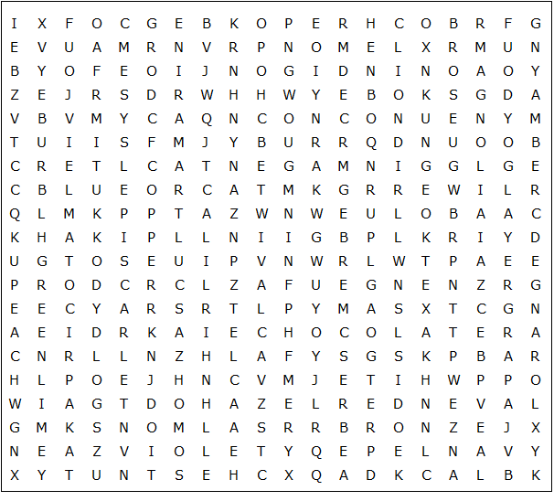

chocolate tangerine burgundy charcoal chestnut olive peach

lavender magnolia apricot crimson magenta scarlet bronze

rose ruby copper indigo maroon orange purple salmon

violet yellow amber black brown cream green hazel jade

silver ivory khaki lilac lemon mauve ochre gold grey red

sepia white blue cyan fawn ultramarine lime navy pink

50 Colours

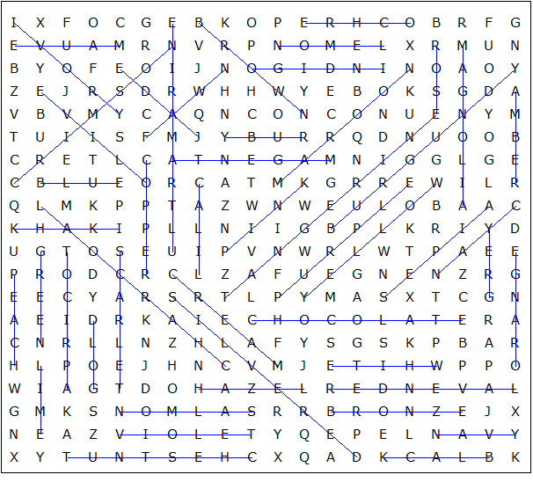

This puzzle was created in seconds using Toolbox, available for only £10 from discoveryeducationalsoftware.co.uk

